SF9 SOLAR TRACKER INSTALLATION MANUAL

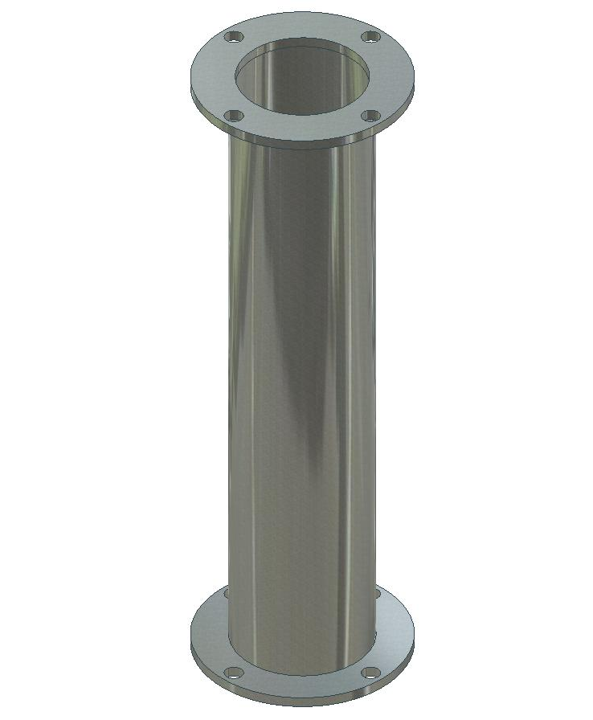

1- Make a concrete foundation, with four M20 threaded rods. They must extend 60 mm out of the concrete. The images below show the distance between the rods.

The foundation, if it is for gravity, can be a 150 cm diameter by 40 cm high concrete block.
If the ground is not very solid the foundation can be 100x100x80 cm. If it is solid, it can be smaller. We can advise you.

Put the column on the four rods.

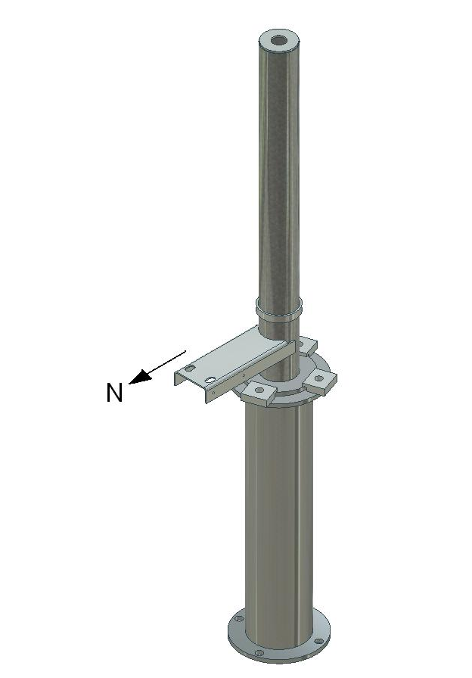

2- The set part must face north, as shown in the image (M20 nuts and bolts).
The 4 bolts have to be tightened to 590 Nm.
Finding a distance reference with a topographical map or a satellite image makes determining north much more precise than with a compass.

3- A concrete column can be used instead of an iron one. In this case it should have M20 rods that come out some 60 mm.
The measurements are in the attached drawing.

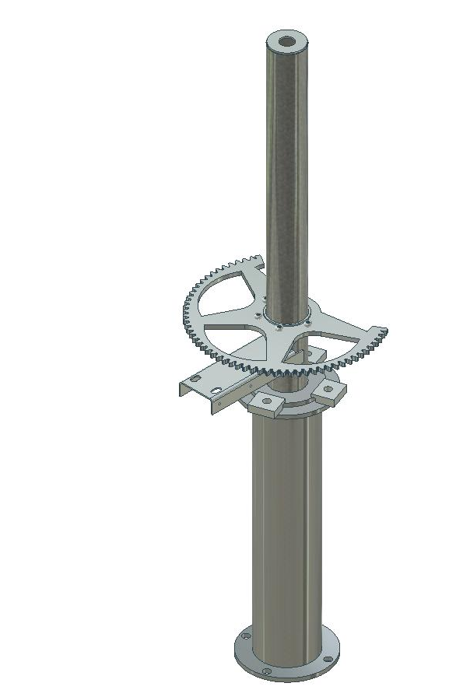

4- Install the time movement wheel.

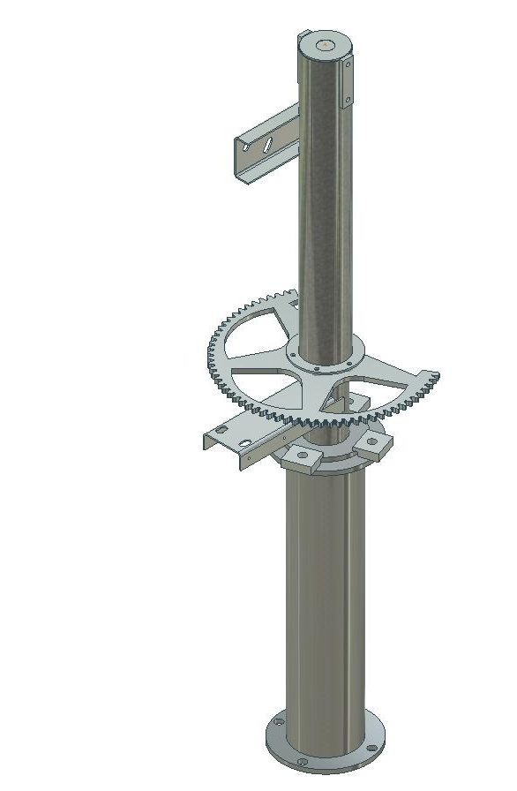

5- Install the mobile tube and fasten the four wheel fastening bolts.
The M10 bolts have to be tightened to 75 Nm.

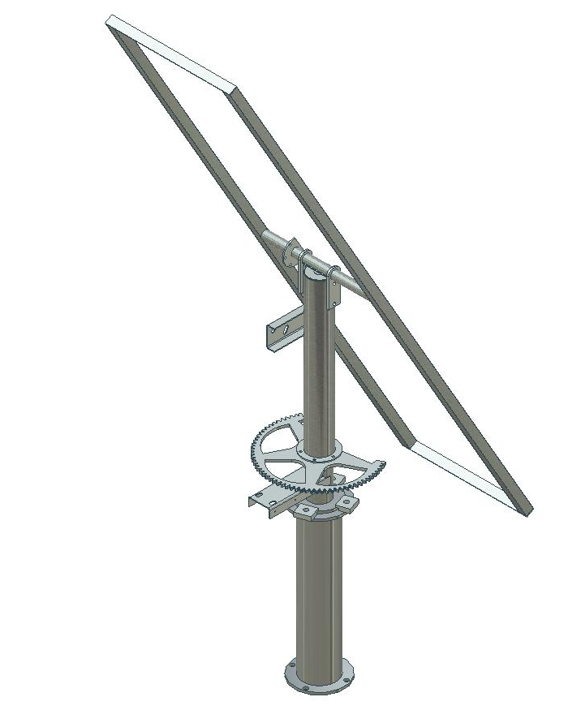

6- Install and attach the “H”.
M12 bolts. Tighten them to 125 Nm.

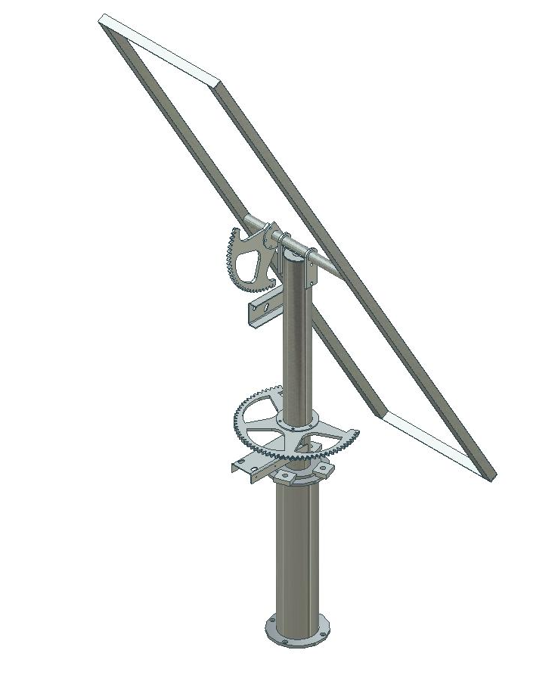

7- Install the tilt axle’s semi-ring.
M10 bolts. Tighten them to 75 Nm.

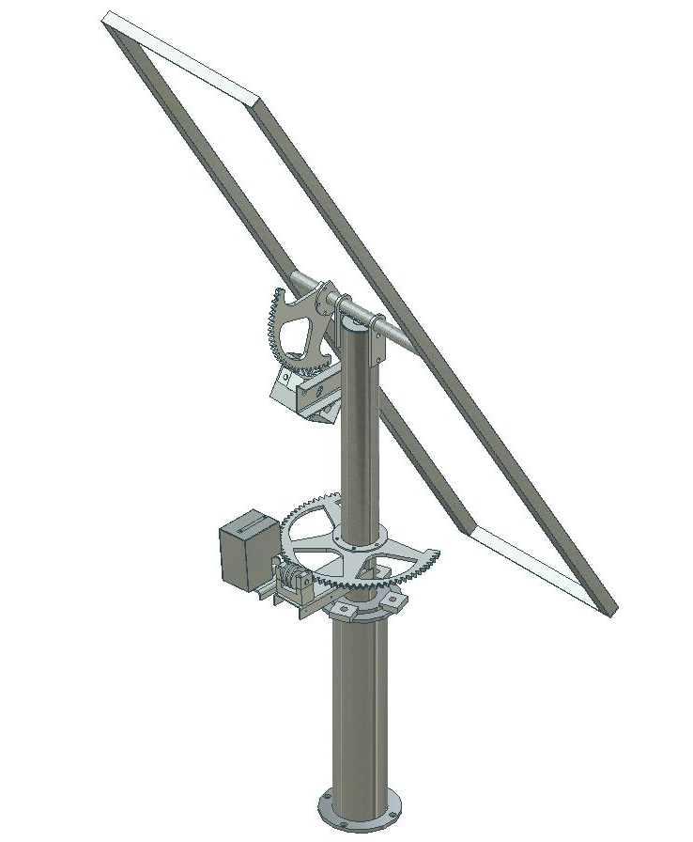

8- Install the system with a worm screw that engages the cog wheel.
M16 bolts. Tighten them to 300 Nm.
Make sure the motor’s power is at 12 volts and that it makes complete movements without getting jammed.

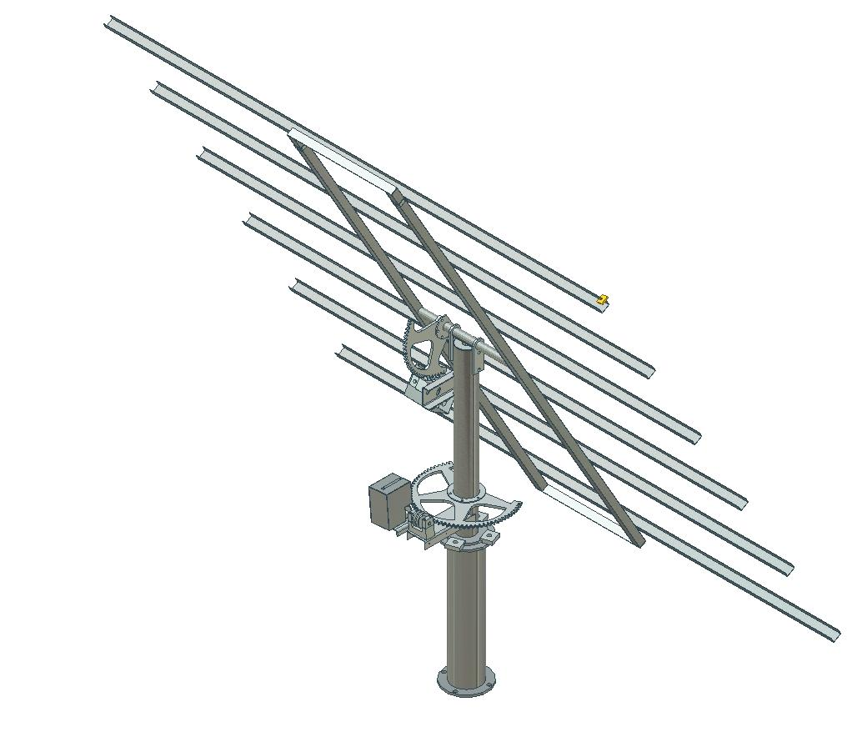
9- Install the electronic box (the electronic box may be linked to the protection of the hourly motor), plug in the motors and switch-counters. Connect the system through the lower opening with a continuous current of 12 volts. The polarity for connecting is indicated with the + and – signs on the interior terminal strip. Be careful when connecting the inverted poles.
Put grease in all gears and points of friction. This is repeated once or twice a year.

10- Turn on the machine (see details further on).
Move the structure until it is horizontal, this will make it easier to attach and set up the grill of bars and the panels.

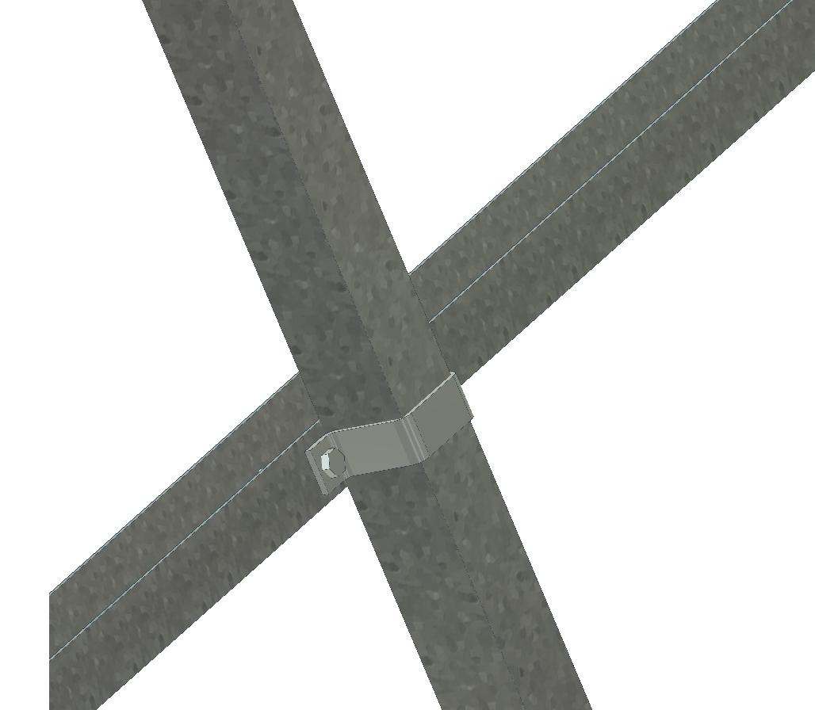

11- Set up the horizontal bar support clamps and install the bars at an adequate distance apart for the panels to fit properly as can be seen in the image.

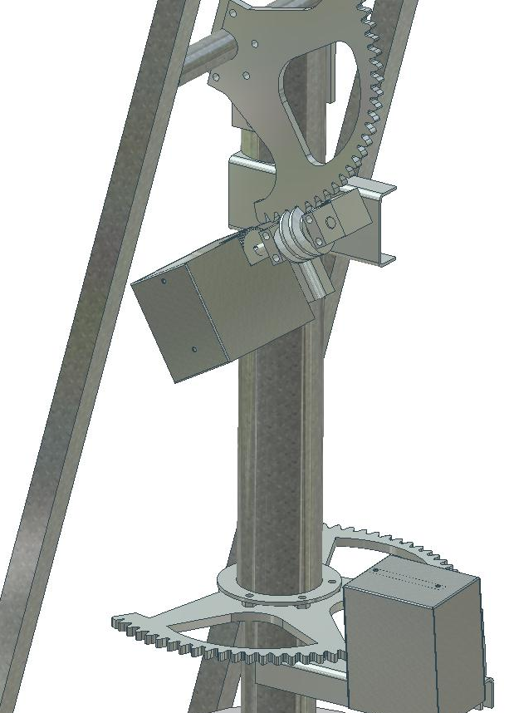

12- Mount the motor protectors.

13- Mount the panels with the clamps supplied as shown in the figure.

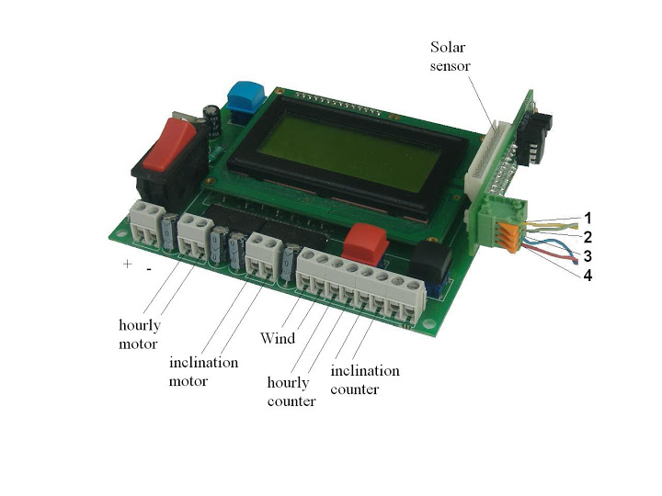ELECTRONICS AND PROGRAMMING

Connect a 1 to 4 mm² gauge wire (see further below) to the terminal strip inside the hermetic box with the electronic system. It is marked with + and –, where the positive and negative are connected. Be careful not to invert the poles. Make the wire pass through the inner opening so that it remains quite hermetic.
If the distance between the power supply (normally battery) to the tracker is shorter than 8 meters, the cable should be 1 mm² gauge. If it is between 8 and 22 meters, install a 2.5 mm² cable. If it is 22 to 40 meters, install a 4 mm² cable.
Two sets of cable with connectors come out of the box. The shortest cable goes to the hourly engine (and its microswitch), and the longest cable goes to the tilt engine.

There is a switch near the terminal strip. It turns on the electronic system. After 2 seconds the following screen appears:

14/05/03 10:21
LON: E001º52`25` `
LAT: N41º42`50``

In other words, day, month, year, hour and minute.
The red button changes the day. Each time it is pressed the number increases one unit. When it reaches 31 it resets to 0.When the day is correct, continue with the black button for the next value to be changed, the month. Proceed as before. Just the same as with the year, hour and minute.
Be careful! You must set the universal time. You can find this by double clicking the clock on your computer and selecting “time zone”, this will give you a universal time (GMT) with respects to the time on your watch in your country.
By the same procedure longitude and latitude must be set up. Remember to set east (E) and west (W) for longitude and north (N) and south (S) for latitude.

At any moment, if the information were correct, you could move directly onto the following screen with the blue button.

Then the following appears:

1 01
Tilt axis
Black: vertical
Red: horizon.

The two ones or zeros that appear in the top right extreme of the screen inform you about the state of the two counter switches. The first number indicates if the revolution counter switch of the tilt axis is activated. (1: connected, 0: disconnected). The second number indicates the state of the hourly revolution counter.

These two numbers can be very useful to know if any switch does not work

With the two buttons, position the tilt axis until achieving the correct inclination with regard to the inclination of the sun in this moment (if it is nigth time or cloudy, it will be best to wait for the sun to come out).

Press the blue button again and the following will appear:

2 01
Hourly axis
Black: east
Red: west

With the two buttons, position the hourly axis until the base faces the sun.

Then, only for solar sensor systems, the screen shows:

HOR:129
VER:123
LLU:085

When it is focused on the sun, the value HOR and VER must be near 128. Value LLU means the light. If it is below a set value, the solar sensor does not work and the tracker works through an astronomical program.

Whether it is by concentration or not, by pressing the blue button you will go to the normal function screen, which will always be activated:
14/05/03 16:21
HOR: +270º 0120
VER: +022º 0001
00 00 120 243 01

On this screen the date, hour and minutes are displayed. By pressing the black button you will increase the minutes and the red button will decrease them.
The following line is the hourly position. 90º is when the tracker faces east, 180º is when it faces south and 270º when it faces west.
Next, on the same line is the number of impulses given by this axis from the start of the day.
The third line is the same but with the axis in vertical movement. It would be 0º if the tracker were completely vertical and 90º completely horizontal.
The numbers on the forth line are control numbers. At any rate, the last number indicates the minutes left to calculate the position of the tracker and begin to operate, and the motors if applicable.
By pressing the blue button you will return to the two previous screens in order to adjust the tracker to face the sun.

MALFUNCTION WARNINGS

When a motor does not work, the tracker gets stuck, the switches fail, etc. the electronic system detects it and an error message appears on the screen while the motors disconnect. There are two possible errors:

ERROR 26: The tilt axis. This error appears on the screen when the electronic system has ordered the tilt motor to start and during several seconds it has not detected any change of state in the revolution counter switch of the engine. It is always open or closed. Therefore, one of the following things has occured:
- The tilt motor does not work
- The connections to the tilt motor have failed
- The switch does not work or fails to activate
- The switch connections have failed
- The tracker is obstructed and therefore cannot move

ERROR 27: The same as in the previous error but with the hourly axis.

In both errors, the number of seconds that remain without receiving a signal change before disconnecting motors and an error notice comes in 6 seconds by default. In any event it is possible to change between 1 and 25 seconds (see later on, the V variable).

CONFIGURATION OF SOME PARAMETERS

By default this tracker is already programmed so that it works perfectly, but it has great flexibility to adapt itself to an infinite number of circumstances. By changing the value of some variables you will be able to extend or to correct functions.
If you want to change variables you will have to do the following:
Press the connection switch and before 2 seconds of connection go by, press the red button.
A screen will appear before you with 8 values, from A to H. With the red button you can change every value and with the black button you can proceed to the following value. When you come to the value H, by pressing the black button you will continue to the following screen where values from I to P will appear, and by the same method a third screen with values from Q to Y.

Some variables are not applicable, others are. The different variables and their uses are enumerated:

A: Clock speed: By default it is 128, values are from 0 to 256. If the clock tends to move forward, drop the value (127, 126, 125). For each unit you drop, the clock will move backward 1.38 seconds daily. And the other way around if you move the value forward.
B (only for concentration): Value of light that is considered sunny. 76 by default. To adjust this value (it may vary with the sensor), point the tracker to the sun (with clear skys) when the sun is 30º above the horizon. The“LLU” value is on the 3rd screen. Subtract 20 from that number. This is the value that must be in parameter B. For example if you see 94 on the screen, variable B is 74.
C: Minimal inclination of the tracker with regard to vertical. By default it is at 22º. The range is 0 to 85º.
Modifying this variable can be useful for several things. For example, if you have an obstacle that interferes when the device is very vertical. If for whatever reasons, you only want the hourly axis to move, you can put this variable to 85º. In European latitudes where the sun never reaches this inclination, the tilt axis will never move.
D (only for concentration): Hysteresis. It can be 3 if a really high accuracy is needed or 25 if not. Less than 3 trackers would have not be stable enough. In the screen with parameters “HOR, VER, LLU”, the first two numbers are the vertical and horizontal axis. The ideal value is 128, if the hysteresis value is 10, it will always be between 118 and 138.
E: Range of movement from east to west. 180º by default. That is to say, from the midday position (south), the range of movement will be +/– 90º. It can be programmed from 0 to 255º.
In the case of 255º it would mean that it would go from –127.5º (northeast) to +127.5º (northwest) in reference to the south. In any case, the tracker does not permit such a wide range of movement.
F: Number of impulses from the switch of the hourly motor to complete its hourly course. The number of impulses that the tracker generates to complete 180º by default. In the SF9, 0267; in the SF20, 0400, and 0641 in the SF45.
For example, if, in an SF20 with a 400 value per 180º, you only want it to do 150º, besides modifying variable E, you will have to modify F, since doing 150º will only create 333 impulses.
G: Time, in minutes, between movements of the tracker. It can be programmed between 1 and 98 minutes. If it is 30 minutes, it means that every 30 minutes it will calculate the position of the sun and, if required, the tracker will move. On the normal operation screen the number on the fourth line to the right indicates the number of minutes remaining until the next calculation.
H: Language. From 1 to 4. Number 4 is English.
I: Night position activation. If it is at 0 the tracker will do its normal day movement and in the evening, when the sun sets, it will turn back towards the east, keeping the tracker in the most possible vertical position (by default 22º). If it is at 1, in the evening the tracker shifts to horizontal. This can be useful for making access to the panels difficult, thus preventing robbery. It can also be useful to minimise the time of vertical position, in which the wind’s action is the strongest. The inclination is what is prommgramed in the wind variable (80º by default).
J (only for concentration): Period of measuring by the solar sensor, in minutes. The default value is 82, and it measures the value every 10 seconds.
K: Not applicable.
L: A useful parameter that helps the tracker to “count” properly the tilt axis when the tracker is not balanced. If the tracker, due to its weight, is often too vertical, it could loose some impulse. This parameter can be set to 2 or 3 (instead of 0 by default).
M: Not applicable.
N: This is the way that the tracker can run from the south position till it reaches the east gear stopper. By default, 106º. This is very useful when there is an automatic restart. If the foundation of the tracker is not pointing perfectly to the north, the value can be changed and get a more precise tracking system.
O: Maximum verticality of the tracker before it reaches the tilt axis stopper. By default, 4º (with regard to the vertical).
P (only applicable to plants where trackers are connected to a network): The identification number of the tracker.
Q: Angle, from vertical, when the wind safety position is set.
R: Not applicable.
S: Not applicable.
T (only applicable to plants where trackers are connected to a network): Identification number for groups of trackers. The individual identification number of each tracker is parameter P. However, if, addionally, you put T = 200 to 10 trackers, T = 201 to ten more trackers, etc., when tracker 200 is called up by the master, the whole group of trackers 200 will obey.
U: Not applicable.
V: Time, in seconds, in which the electronic system are not receiving a signal to show the error. By default, 6 seconds. It can be adjusted between 1 and 25 seconds.
X: Time, in minutes, by which the tracker will set itself horizontally if given the order because of the wind. By default, 60 minutes. Values adjust from 10 to 190 minutes.

In the electronic system there is a terminal strip of two contacts, indicated with a “V”. If the circuit closes between these two contacts, the tracker will set itself horizontally during the programmed time. If you have an anemometer that closes a circuit at a certain wind speed, it will allow you to use this system for major protection from winds.
There is another terminal strip that sends a signal when it detects an operation error.

SEMIAUTOMATIC STARTUP:

One way to start up the trackers semiautomatically is as follows (if the position, date and hour are correctly set up):
- Switch on the electronic system.
- Press the blue button before 2 seconds have passed by.

The tracker will start moving to the east till the stopper of the gear stops it. Once it stops it will take that point as a reference. After this it will go to the west till the point it should be according the time. The same procedure will be done with the tilt axis and it will operate normally with no need to press any other command.
The inclination of the tracker cannot be vertical in the semi automatic startup
(A17 version)

Trackers Feina SL,

Fàbrica el Molinet s/n

08250 Sant Martí de Torruella(Barcelona)

Tel:93 875 1001
feina@tracker.cat
http://www.tracker.cat

