SF70-1EH SOLAR TRACKER INSTALLATION MANUAL

1- Place the concrete blocks; if they are not poured, the three central blocks can be 35x35x400 cm and the two with the tips can be 35x35x300cm.
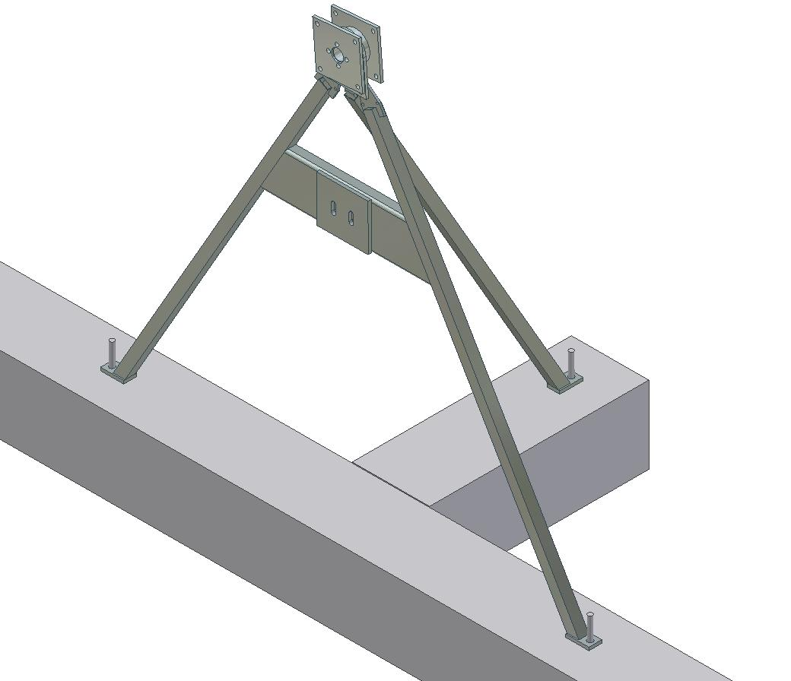
M18 10 cm long threaded rods will come out of the concrete blocks. The measurements for spacing the threaded rods are indicated in the drawing.
They have to be placed so that the axis of the tracker is aligned north to south.

2- Place the 3 central feet and rotating set of the upper part.

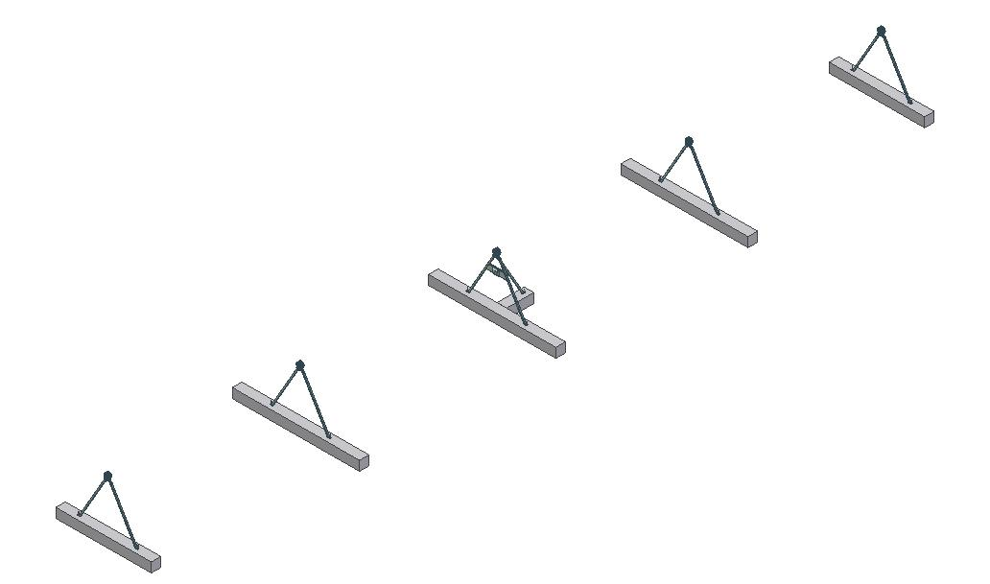

3-Repeat with the other feet.

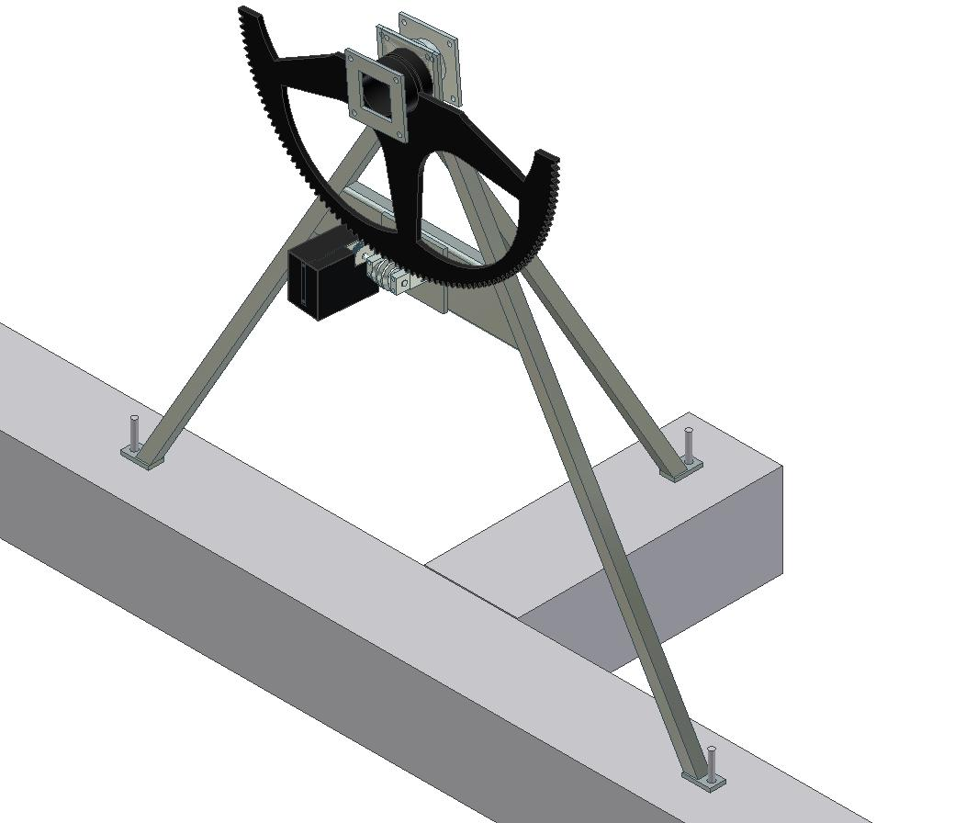

4-Screw the cogged wheel and then the motor set with a worm screw.
Make sure the motor’s power is at 12 volts and that it makes complete movements without getting jammed.

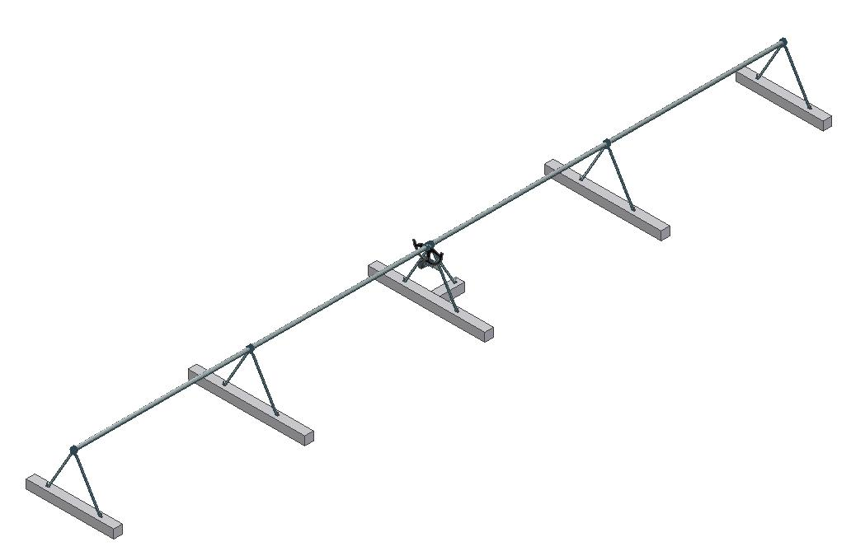
5- Place the pipes among the legs, so that the bars that are longitudinally welded to the pipes remain horizontal, as can be seen in the following images.
Put grease in all gears and points of friction.
This is repeated once or twice a year.

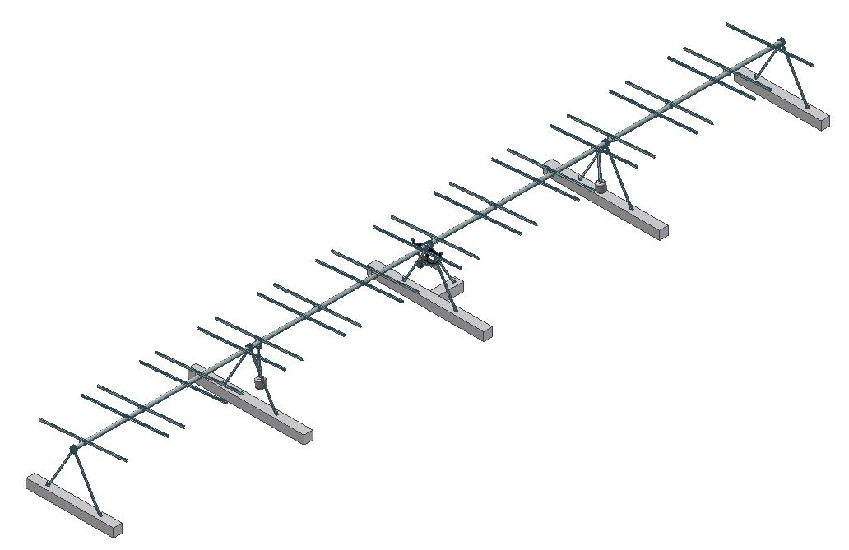

6- Install the transversal bars that are used for clamping the panels, by means of the plates that are seen in the following image. Additionally, the counterweights have to be put approximately where the image shows.

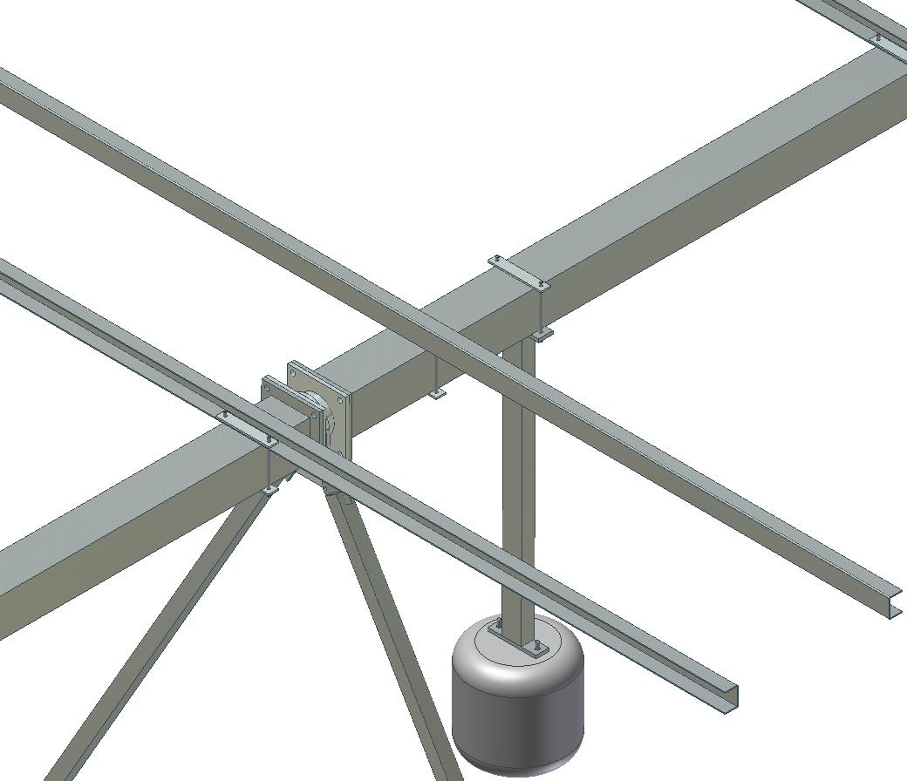

7- Detail of how the bars and the counterweights are placed.

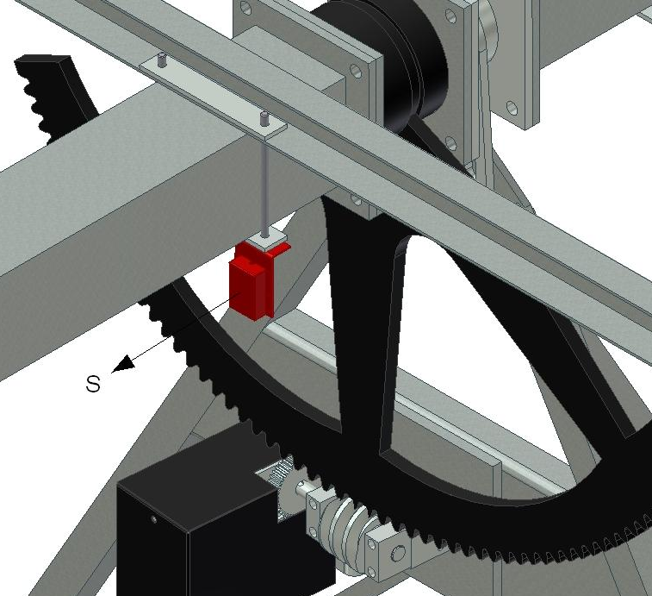

8- Next, put the inclinometer with the guidance showed in the image. It can be put in any place of th 24 mts of the tracker axis.

9- Mount the panels with the clamps (anti-theft) supplied as shown in the figure.

Note: It could be much more cost effective for a solar plant with many trackers to put 5 beams anchored to the ground, instead of installing a concrete foundation. We can advise you.

ELECTRONICS AND PROGRAMMING

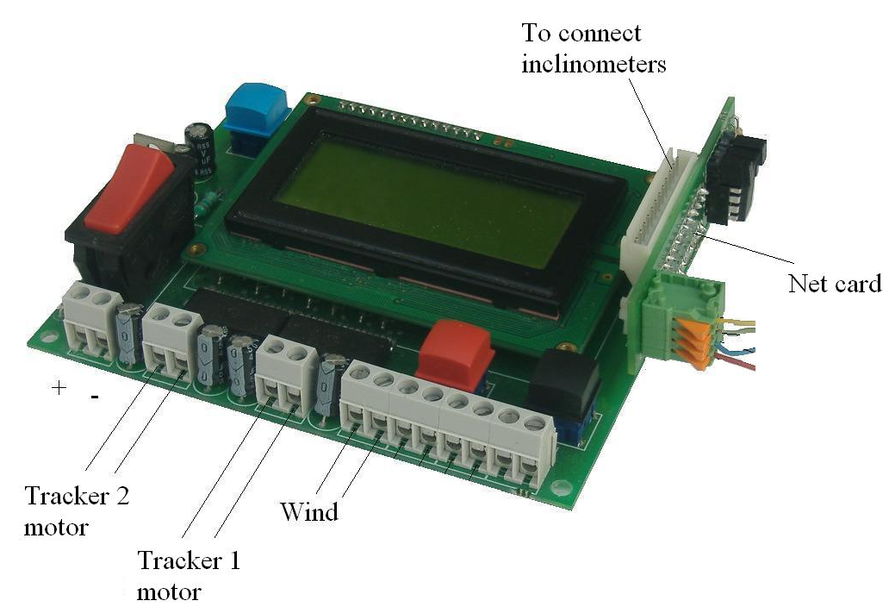
Connect a cable from 1 to 4 mm2 section (see below) in the strip on the left (+ and -). Be careful not to reverse the poles. The cable is passed through the bottom hole so that it is fairly airtight.
In the picture is showed where are connected the motors of both trackers. If the electronic only control one tracker, it should be connected the number 1.
On the right side of the plate should be connected the net card (if the trackers are connected by net) and the inclinometer cards. One inclinometer if there is only one tracker and two if there are two trackers.
Order of connection does not matter. The inclinometers could be put the first and then the net card, or vice versa.

Implementation

If there are connected GPS and control by net, only press the power switch (on the left of the image), the trackers starts and you should not do anythingelse.
Whats is it doing?
First it goes to the east until the landmark mechanical. Then goes to the west to find the next landmark mechanical. With this, it has the reference of the tour. It saves and it never needs to do it again. Then it goes to the horizontal position. After that take note of the dates sent by GPS (latitude, longitude, day and time) and it goes to the right position.
If there is not GPS or it take wrong dates from it, it will do the same movements to have reference and it will stop in a horizontal position.
Then you stop. You press again the power switch and it appears, after 2 seconds the following screen:

14/05/03 10:21
LON:E001º 52’ 25’’
LAT:N41º 42’ 50’’

That is, day, month, year, hour, minute, latitude and longitude.
With the red button will change the day. Each press will increase the number by one. When you reach 31 is put back to 0. When we have the right day, with the black button will pass to the next value to change the month. We proceed in the same way.

Just as in the year, hour and minute
Attention! We set the universal time. Double clicking on the watch from your computer, and selecting "zone" will have an orientation of Greenwich Mean Time (GMT) on the clock hour of your country.

With the same procedure will get the longitude and latitude of the place, taking into account the need to put east (E) or west (W) in length and north (N) or south (S) latitude.
At any time, if the data were correct, a blue button would pass directly to the next screen.

Then it appears:
Seguidor 1
Negre:est
Roig :oest.

With both buttons we can move tracker n. 1 manually.

With the blue key:
Seguidor 2
Negre:est
Roig :oest.

To move the tracker n. 2.

We press the blue one again and it will appear:

HOR:129
VER:000
LLU:085

This is only useful when it incorporates a solar probe concentration. When properly focused on the sun, the HOR value is close to 128. LLU value is the value of light.If below a certain value, the probe does not act and only moves by astronomical program.

Even with concentration or without, with the blue button will move to the normal operating screen. Which will be always active:
14/05/03 16:21
ANG:48,26º
1:48,15º 2:48,18º
00 00 328 310 08

This screen shows date, hour and minute. Pressing black will move the minute black and the delay by pressing the red.
The next line is the calculated angle which the tracker have to have.
The third line indicates the position must be each tracker, number one and two. If the trackers if facing east, angle will be between 0º and 90º. When it is horizontal, midday position, angle will be 90º and when it is facing west, angle will be between 90º and 180º. In the time it rises the Sun is 0 ° at solar noon, the tracker must be horizontal, is 90 degrees and at night, when sunset, will be west to 180 º.
The fourth line numbers are numbers of control. In any case the last number of minutes reported missing to calculate the position of the tracker and is lit, if applicable, the engine.
Pressing the blue back to previous screens to adjust the tracker facing the sun
MALFUNCTION WARNINGS
When an motor doesn’t work, or the tracker gets stuck or the switches fail, etc. the electronics detects it and an error message appears on the screen while the motors disconnects. There are two possible errors:

ERROR 1: This error appears on the screen when the electronics has ordered the motor of the tracker 1 to the east and during several seconds it has not detected any change of position of the tracker. From which it is deduced that one of the following things could occur:
- The inclination motor does not work
- The connections to the inclination motor fail
- The inclinometer does not work
- The connexions of the inclinometer fail.
- The tracker is obstructed and therefore cannot move
ERROR 2: The same as in the previous error but in west direction.
ERROR 3: tracker n. 2, east direction
ERROR 4: trakcer n. 2, west direction

CONFIGURATION OF SOME PARAMETERS
By default this tracker already comes programmed so that it works perfectly, but it has a great flexibility to adapt itself to an infinite number of circumstances.
By changing the value of some variables we’ll be able to extend or to correct functions.
If we want to change variables we’ll have to do the following:
Press the connection switch and before 2 seconds of connection goes by, press the red button.
A screen will appear before us where there are 8 values, from A to H. With the red button we can change every value and with the black button we can proceed to the following value. When we come to the value H, by pressing the black button we’ll continue to the following screen where the values from I to P will appear, and by the same method a third screen with values from Q to X.

Some variables are not applicable, other are. Here is an enumerated list of the different variables and their uses:

A: Clock velocity: By default it is 128, values are from o to 256. If the clock tend to move forward, to drop the value (127, 126, 125). For each unit we drop, clock will move backward 1.38 seconds daily. And will the other way around if we move forward the value.
B: (only for concentration) Value of the light of the sun. By default 76, usually a powerful sun it is 95. To adjust this value (that it may vary with the sensor), point the tracker to the sun (with clear sky) and sun above 30º. Write down the value “LLU” on the 3rt screen. Of than number take out 20. An this is the value that must be in parameter B. For example is “LLU” is 94, parameter B must be 74
C: Minimal inclination of the tracker with regard to the vertical one. By default it’s at 32º. The status goes from 0 to 85º.
D: (only for concentration) hipster. It can be 3 if a really high accuracy is needed or 25 if is not needed. Below 3 tracker would have not enough stability. In the screen with parameters “HOR, VER LLU”, the first two numbers are the vertical and horizontal axis. The ideal value is 128, if the hipsters value is 10, it will always be between 118 and 138
E: Not applicable
F: Not applicable
G: Time, in minutes, between movements of the tracker. It can be programmed between 1 and 98 minutes. If it’s 30 minutes, it means that every 30 minutes it will calculate the position of the Sun and if they correspond, the tracker will move. On the normal functioning screen the number that on the fourth line to the right indicates the number of minutes remaining until the next calculation.
H: Language. From 1 to 4. Number 4 is English
I: Night position activation. If it’s at 0 the tracker will do its normal day movement and in the evening, when the Sun set, it will turn to the back towards the East, keeping the tracker in next closest vertical position (by default 32º). If it’s at 1, in the evening the tracker shifts to horizontal. This can be useful to make the access to the panels difficult avoiding robbery.
J: (only for concentration) Period of measuring of the solar sensor, in minutes. The default value is 82, and it measures the value every 10 seconds.
K: Not applicable
L: A value which is related with rotation speed of the tracker. This value will be used by the system to know if the engine goes faster or slower than the normal speed, and if it is almost stopped and it goes to Error. To SF70, the value should be 10,9 and to SF40 should be 15.3
M: Not applicable
N: Not applicable
O: Maximum verticality of the tracker before it shocks with the inclination gear stopper. By default 30º
P: Only applicable for tracker connected on net. The identification number of the tracker.
Q: Angle, from vertical, when the wind safe position is set.
R: backtracking. This variable is so that tracker can be put very close together, so that in the morning and afternoon, electronics calculates the optimum inclination is not to make shadows. The value to be set is the tracker axis ratio divided by width of panels on each tracker. For example, if we are among trackers distance is 7.5 meters, width is 3 meters, the variable should be 7.5 / 3 = 2.5.
If the value placed is less than 1.0, the machine will be deemed not backtracking.
S: If it is 1, it will only control 1 tracker; if it is 2, one electronic will control 2 trackers.
T: not applicable
U: Not applicable
V: Not applicable
X: Time, in minutes, by which the tracker will set itself horizontally if given the order because of the wind. By default 60 minutes. Values adjust from 10 to 250 minutes.
Y: Second number of identification of the network. It is useful to make groups that obey one order from the control unit of the network. As example: if one group of 10 trackers we put 88, when we send and order from the central, will oby all 10 trackers.
AA: Safety of the working and to use supercapacitors instead of batteries. It is the minimum working voltage. If the voltage lows, the tracker will stop waiting that it goes up until to get the value said to AC. By default this value is 9,00 V.
AC: voltage which from that the tracker starts to normal work. By default is 12,0
AD: not applicable

In the electrical grid there is a wire shaft of two contacts, one indicated with "Wind” showed in the picture that if the circuit closes between these two contacts, the tracker will set itself for us horizontally during the programmed time. If we have an anemometer that at a certain wind speed closes a circuit, it will allow us to use this system for major protection from winds.
If the tracker is connected to the net, you do not do that, it is the central control which has the anemometer and give the order of the wind.
Also there is a wire shaft that when it detects a error in the work, gives a signal.
AUTOMATIC INITIALIZATION:

The first time that we connect the tracker will make the initialization automatically. If we want to do after, we should do the next:
Press the switch and before one second, pree once the blue key.
If there is GPS and we want that it takes the dates from GPS and tracker takes the right position we will do:
Press the switch and before one second, press the blue key more than 5 seconds. When we stop pressing, it will take the dates from GPS and will take the position.
Every day, at night, GPS will update that exact time.
All functions (also the GPS initialization) can be done from a central unit of control that connects all the trackers
(A01 version).

Trackers Feina SL,

Fàbrica el Molinet s/n
08250 Sant Martí de Torruella (Barcelona)

Tel: + 34 93 875 1001
feina@tracker.cat
http://www.tracker.cat

